

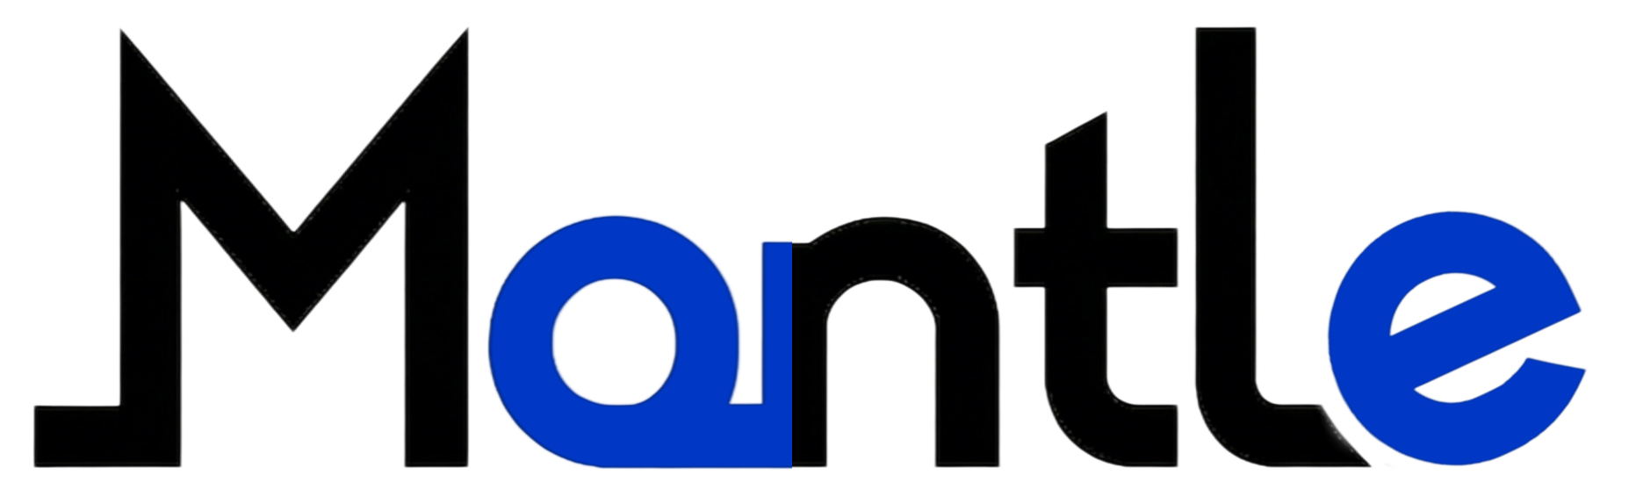
Mantle Technical White Paper
Connecting Traditional Finance with Web3
(Technical Whitepaper) v1.0

Technical White Paper

Mantle Technical Whitepaper v1.0

Mantle Network is a decentralized protocol specifically designed for industrial-grade Real-World Assets (RWA). It achieves real-time anchoring between physical mining data (IoT Data) and on-chain asset issuance (Token Minting) through its proprietary Proof of Physical Work (PoPW) consensus mechanism. This document provides a detailed exposition of Mantle's technical architecture, including the M-RWA token standard, oracle node network, and Solidity-based core smart contract implementation.

1. Overview of Core Architecture (System Architecture)
Mantle's technology stack consists of three layers:
- Physical Layer: IoT sensor network deployed in Laos mining areas, including weighbridges, flow meters, and GPS trackers.
- Middleware Layer: Handles data cleansing, signature verification, and oracle transmission.
- On-chain layer: A cluster of smart contracts deployed on Ethereum/Layer 2 that handles asset creation, destruction, and trading.
1.1 Logical Flow of Data Trustworthiness
The data flow from the mine to the blockchain follows this path:
IoT Device (Sign Data) -> Mantle Edge Node (Batching) -> Chainlink/API3 Oracle -> Mantle Core Contract -> Token Minting.

2. M-RWA Asset Protocol Standard (The M-RWA Protocol)
To centralize the management of eight major mineral resources, we developed the ERC-20-M (Mantle Standard) protocol instead of using the standard ERC-20. This enhanced standard incorporates modules for asset auditing, capacity linkage, and compliance restrictions.
Connecting Traditional Finance with Web3

2.1 Core Interface Definition
Connecting Traditional Finance with Web3

Connecting Traditional Finance with Web3

2.2 Technical Analysis: Why Interface Expansion is Necessary
- The standard ERC-20 lacks the capability to describe 'asset endorsement'. The IMantleRWA interface mandates that every mint operation must include proofData.
Technical White Paper
Connecting Traditional Finance with Web3

- proofData: An encoded byte string containing the IoT device's unique ID, timestamp, weight reading, and ECDSA private key signature.
- ipfsHash: All original documents (e.g., waybills, lab reports) are uploaded to IPFS distributed storage, with their hash values permanently recorded on-chain for auditing agencies to access at any time.
- Proof of Work (PoW) Core Contract:
- This is the core of Mantle. The contract verifies the authenticity of IoT data from mining operations, preventing the falsification of production metrics.
3.1 Verification Logic

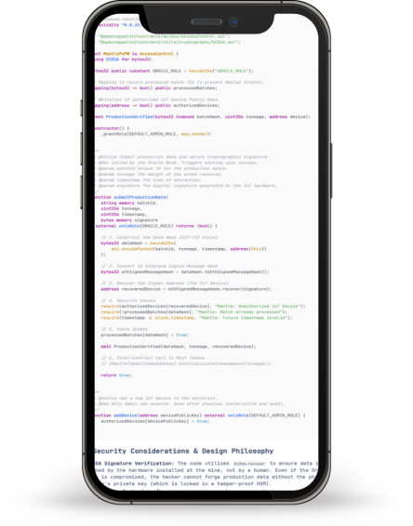
2.3 Technical Depth Analysis
- ECDSA signature verification: The code employs ECDSA.recover to verify that data is genuinely issued by the hardware installed in the mining facility, not forged by hackers. Even if the oracle node is compromised, hackers cannot forge production data as long as the IoT device's private key (stored in the Hardware Security Module, HSM) remains unexposed.
- Anti-Replay: The processedBatches mapping table ensures each production data packet is used only once, preventing malicious nodes from resubmitting the same batch of ore data to fraudulently obtain double tokens.
- Timestamp verification: Enforces timestamp checks to ensure real-time data and prevent malicious use of historical data.
4. Dynamic Supply and Destruction Mechanism (Elastic Supply Engine)
Mantle's token economy model operates dynamically. The following code demonstrates how to automatically burn tokens based on the repurchase funds from the HashKey exchange.

Technical White Paper
Connecting Traditional Finance with Web3

4.1 Auto-Buyback & Burn Contract
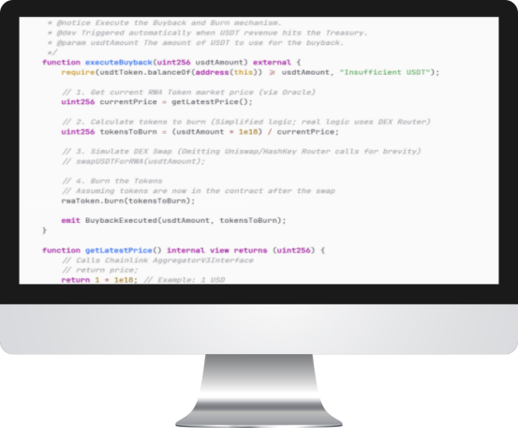
4.2 Economic Model Coding
This code enshrines Mantle's business logic as an unalterable rule:' Profits must be reinvested.'

- Traditional companies may break their promises and not pay dividends.
- Once deployed, the MantleTreasury contract allows anyone to execute the executeBuyback function (or be triggered by an automated Keeper) upon USDT entering the contract address, enforcing the token destruction logic to safeguard token holders' rights.
5. HashKey Compliance Integration
To comply with Hong Kong's Securities and Futures Commission (SFC) regulations, Mantle's token contract incorporates a compliance verification layer.

5.1 Restricted Transfer Modifier
Technical White Paper
Connecting Traditional Finance with Web3

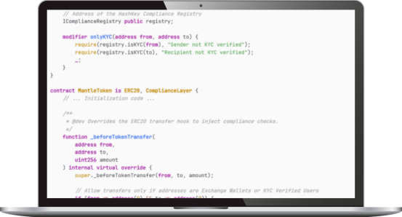
Technical White Paper
Connecting Traditional Finance with Web3

5.2 Regulatory-Friendly Design
- KYC Verification: Through the IComplianceRegistry interface, Mantle can access the user database of HashKey in real time (in anonymized hash format). This ensures that only KYC-approved users can hold or trade specific RWA tokens, such as security tokens.
- Upgradeability: Regulatory policies are subject to change. We have decoupled compliance logic into standalone contracts. When regulatory policies are adjusted, we only need to update the logic pointed to by ComplianceRegistry, without requiring token reissuance.
6. Sapphire NFT Casting Standard (Luxury NFT Standard)
- For #05 Sapphire assets, we adopted the ERC-721 standard and implemented metadata extensions.

6.1 Gem Metadata Structure
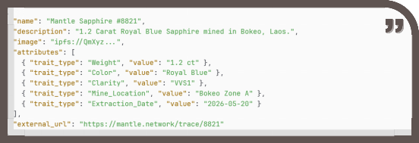
Technical White Paper
Connecting Traditional Finance with Web3

Mantle Technical White Paper

6.2 Casting Contract Section
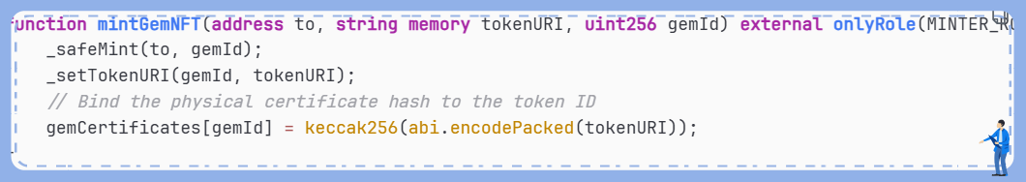

7. Conclusion and Outlook
The Mantle white paper demonstrates a highly sophisticated and rigorous engineering framework. We are not merely issuing tokens, but establishing a translation protocol between the physical and digital worlds.

- Security: ECDSA signature and replay protection ensure the source data is tamper-proof.
- Transparency: Every ton of mineral output and every repurchase transaction is publicly verifiable on the blockchain.
- Compliance: Mantle's native KYC layer enables seamless integration with licensed financial institutions like HashKey.

Mantle's codebase will be fully open-sourced and undergo dual audits by CertiK and SlowMist to ensure the secure management of assets with a scale of hundreds of billions.

